**1. Project Selection & Team Formation**

The project selected for this course is **"Cybersecurity Incident Reporting & Response System (CIRRS)."**  
The project aims to address the challenges in managing cybersecurity incidents in organizations by providing a centralized platform for reporting, tracking, and responding to security incidents.

This project was chosen because it addresses a critical real-world problem in cybersecurity management and demonstrates the application of software engineering principles, including system analysis, requirement specification, and design using UML and CASE tools

**Team Formation and Assigned Roles**

The project team was formed with the following roles and responsibilities:

| **Team Member** | **Assigned Role** | **Responsibilities** |
| --- | --- | --- |
| Manasa B | Project Manager | Project planning, task allocation, progress tracking, coordination among team members |
| Ananya Ramesh | Documentation Lead | Preparation of SRS, design documents, reports, and maintaining documentation consistency |
| Mohan Krishna | Lead Developer | System design logic, module planning, and technical implementation guidance |
| J Prethi Chanddana | QA Lead | Requirement verification, review of documents, quality assurance, and validation of system design |

These roles ensure clear accountability, efficient workflow, and timely completion of the Cybersecurity Incident Reporting & Response System Project.

**2. Team Agreement Creation**

A team agreement was created to define working norms, responsibilities, and collaboration rules for the development of the Cybersecurity Incident Reporting & Response System. This agreement ensures smooth teamwork, accountability, and effective communication throughout the project lifecycle.

**Team Working Norms**

* All team members will actively participate in project-related activities.
* Tasks will be distributed equally among team members.
* Regular discussions will be conducted to track progress.
* All decisions will be made collectively by the team.
* Any issues or conflicts will be resolved through mutual discussion.

**Communication Guidelines**

* Team members will communicate through regular meetings and online platforms.
* Important updates and changes will be shared with all members.
* Deadlines will be respected and followed strictly.

**Quality and Responsibility Agreement**

* Each member is responsible for completing assigned tasks on time.
* Work submitted by any member will be reviewed by at least one other member.
* The team agrees to maintain academic honesty and originality.

This team agreement was accepted by all members to ensure disciplined, collaborative, and efficient project execution.

**3. Problem Statement Development - Define project title, problem, solution, target users, and value proposition**

### Project Title : Cybersecurity Incident Reporting & Response System (CIRRS)

### ****Problem Description:****

### In today's digital landscape, organizations face an increasing number of cybersecurity threats, ranging from phishing attacks to sophisticated ransomware. The traditional methods of incident reporting and response are often fragmented, relying on emails, spreadsheets, and manual processes. This leads to:

### Delays in incident reporting and response

### Lack of real-time visibility for stakeholders

### Inefficient coordination among security teams

### Poor documentation for compliance and audit purposes

### Increased risk of data breaches and financial losses

### ****Proposed Solution:****

### The Cybersecurity Incident Reporting & Response System (CIRRS) is a centralized digital platform that streamlines the entire incident management lifecycle. It allows employees to report incidents, classifies incidents based on severity, assigns them to appropriate security personnel, and tracks the response process in real time. The system includes automated workflows, notifications, and comprehensive reporting capabilities.

### ****Target Users:****

### Employees: To report security incidents easily and track their status.

### Security Analysts: To triage, investigate, and respond to incidents.

### SOC (Security Operations Center) Team: To manage and monitor security incidents.

### IT Administrators: To configure and maintain the system.

### Management: To view reports and dashboards for decision-making.

### ****Value Proposition:****

CIRRS provides significant value by reducing the time to detect and respond to security incidents, improving collaboration among security teams, ensuring compliance with regulatory requirements, and enhancing the overall security posture of the organization.

**4. Stakeholder Analysis - Identify primary and secondary stakeholders**

Stakeholder analysis involves identifying individuals or groups who have an interest in or are affected by the Cybersecurity Incident Reporting & Response System. These stakeholders are categorized as primary and secondary based on their level of direct involvement with the system.

**Primary Stakeholders:**

1. **Employees**: Report security incidents and track their resolution.
2. **Security Analysts**: Triage and respond to incidents, use the system daily.
3. **SOC Team**: Monitor and manage security incidents, use the system for coordination.
4. **IT Administrators**: Configure and maintain the system, ensure its availability

**Secondary Stakeholders:**

1. **Management**: Benefit from improved security posture and compliance.
2. **Legal & Compliance Team**: Ensure incidents are handled in accordance with regulations.
3. **External Auditors:** Review incident reports and compliance documentation.
4. **Software Developers:** Maintain and enhance the system.

**5. Stakeholder Interests Documentation - Document stakeholder interests and influence**

### ****Stakeholder Interests and Influence****

| **Stakeholder** | **Interests** | **Influence Level** |
| --- | --- | --- |
| Employees | Easy reporting, quick resolution, transparency | Medium |
| Security Analysts | Efficient triage, clear workflows, reduced manual work | High |
| SOC Team | Real-time monitoring, coordinated response, comprehensive reporting | High |
| IT Administrators | System reliability, security, ease of maintenance | Medium |
| Management | Risk reduction, compliance, cost-effectiveness | High |
| Legal & Compliance | Adherence to regulations, proper documentation | Medium |

# **5 Stakeholder Register Creation**

**Create formal stakeholder register**

| **Stakeholder** | **Role** | **Interests** | **Influence Level** |
| --- | --- | --- | --- |
| Employees | End Users | Easy reporting, quick resolution, transparency | Medium |
| Security Analysts | System Users | Efficient triage, clear workflows, reduced manual work | High |
| OC Team | System Users | Real-time monitoring, coordinated response, comprehensive reporting | High |
| IT Administrators | System Maintainers | System reliability, security, ease of maintenance | Medium |
| Management | Sponsors | Risk reduction, compliance, cost-effectiveness | High |
| Legal & Compliance | Compliance Oversight | Adherence to regulations, proper documentation | Medium |

**7. Scope Definition**

**Document in scope features:**

The in-scope features define the functionalities that are included in the Cybersecurity Incident Reporting & Response System.

1. Incident Reporting: Employees can report security incidents through a web form.
2. Incident Triage: Security analysts can assess and prioritize incidents.
3. Incident Assignment: Incidents can be assigned to specific analysts or teams.
4. Response Workflow: Guided workflows for common incident types (e.g., phishing, malware).
5. Real-Time Dashboard: Display active incidents, status, and key metrics.
6. Notification System: Alerts and notifications for new incidents and updates.
7. Reporting and Analytics: Generate reports on incident trends, response times, etc.
8. User Management: Role-based access control for different user types.

**Document out-of-scope features:**

The out-of-scope features define the functionalities that are not included in the CIRRS.

1. **Network Monitoring**: The system does not monitor network traffic for threats.
2. **Vulnerability Scanning**: The system does not scan for vulnerabilities in the infrastructure.
3. **Endpoint Detection and Response (EDR)**: The system does not include EDR capabilities.
4. **Threat Intelligence Feeds**: The system does not integrate with external threat intelligence platforms.
5. **Automated Remediation**: The system does not automatically remediate incidents (e.g., isolate infected machines).
6. **Mobile Application**: The system is web-based only; a mobile app is not included in the initial version.

**9. Scope Boundaries Document**

**Included Within Scope:**

* Reporting of cybersecurity incidents by employees
* Triage, assignment, and tracking of incidents
* Guided response workflows for common incident types
* Real-time dashboard for monitoring incident status
* Notifications and alerts
* Reporting and analytics for incidents
* User authentication and role-based access control

### ****Excluded from Scope:****

### Network monitoring and intrusion detection

### Vulnerability assessment and scanning

### Automated incident remediation

### Integration with third-party threat intelligence

### Mobile application for incident reporting

### ****System Boundaries:****

The system is a web-based application focused on the management of cybersecurity incidents from reporting to resolution. It does not include proactive threat detection or automated response actions.

**10. SRS Introduction Section - Document purpose, scope, definitions/acronyms**

**1. Purpose**

This Software Requirements Specification (SRS) document defines the functional and non-functional requirements for the Cybersecurity Incident Reporting & Response System (CIRRS). It is intended to be used by the development team, testers, project managers, and stakeholders to understand the system's capabilities and constraints.

**2. Scope**

The CIRRS is a web-based system designed to manage cybersecurity incidents within an organization. It supports incident reporting, triage, assignment, response, and reporting. The system is limited to incident management and does not include proactive security measures.

**3. Definitions and Acronyms**

| **Term Acronym** | **Description** |
| --- | --- |
| CIRRS | Cybersecurity Incident Reporting & Response System |
| UI | User Interface |
| Incident | A security event that compromises the confidentiality, integrity, or availability of information |
| Triage | The process of assessing and prioritizing incidents |
| SOC | Security Operations Center |
| SLA | Service Level Agreement |

**11. SRS Overall Description - Document product perspective, functions, user characteristics, constraints**

### This section describes the overall perspective, major functions, user characteristics, and constraints of the Cybersecurity Incident Reporting & Response System.

### 1. Product Perspective

The Cybersecurity Incident Reporting & Response System is a standalone, web-based application designed to provide a centralized platform for reporting, managing, and responding to cybersecurity incidents within an organization. The system serves as a digital command center for employees and Security Operations Center (SOC) teams to track incidents throughout their lifecycle from detection to resolution.  
It operates independently of core business systems while ensuring secure access, standardized workflows, and real-time visibility for all stakeholders.

### 2. Product Functions

### The primary functions of the system include:

### Incident reporting by employees and stakeholders

### Automated incident severity classification

### Centralized incident tracking and lifecycle management

### Guided response workflows for SOC teams

### Real-time administrative dashboard for monitoring threats

### Audit trail generation and compliance documentation

### Risk analysis and incident reporting for decision-making

### 3. User Characteristics

**General Employees / Reporters:**  
Have minimal technical expertise and require a simple, user-friendly interface to report security incidents quickly.

**SOC Analysts:**  
Possess high technical knowledge and cybersecurity expertise. They require detailed incident data, response tools, and workflow guidance.

**System Administrator / Security Manager:**  
Are experienced in system monitoring, compliance management, and report analysis. They oversee system configuration, user roles, and audit reviews.

### 4. Constraints

### The system requires a secure and stable internet connection.

### Must comply with organizational security policies and regulatory standards.

### Data privacy and access control must be strictly enforced.

### The system is limited to incident reporting and response management and does not perform direct threat mitigation.

### Dependence on secure servers and infrastructure for availability and reliability

**12. Functional Requirements Documentation - Document FR-01 through FR-n with acceptance criteria**

The functional requirements define the core capabilities that the **Cybersecurity Incident Reporting & Response System** must provide to enable effective incident reporting, tracking, response coordination, and compliance management.

**FR-01: Incident Reporting**

**Description:**

The system shall allow employees and authorized users to report cybersecurity incidents through a standardized digital form.

**Acceptance Criteria:**

* User can successfully submit an incident report
* Incident details (type, description, timestamp) are captured
* A unique incident ID is generated
* Incident is stored in the centralized system

**FR-02: Incident Severity Classification**

**Description**:

The system shall automatically classify incidents based on severity levels such as low, medium, high, or critical.

**Acceptance Criteria**:

* Severity is assigned based on predefined rules
* Severity level is visible to SOC analysts and administrators
* Classification occurs immediately after incident submission

**FR-03: Incident Tracking and Status Management**

**Description:**  
The system shall track incidents throughout their lifecycle, from detection to resolution.

**Acceptance Criteria:**

* Incident status updates are recorded (New, In Progress, Resolved, Closed)
* Status changes are visible in real time
* Incident history is maintained without data loss

**FR-04: Guided Response Workflow**

**Description:**

The system shall provide structured response workflows to assist SOC teams in managing incidents.

**Acceptance Criteria:**

* Workflow steps are displayed based on incident severity
* SOC analysts can follow and update response steps
* Completion of each step is recorded in the system

**FR-05: Notification and Alert Management**

**Description**:

The system shall notify relevant stakeholders when incidents are reported or updated.

**Acceptance Criteria:**

* Alerts are triggered on incident creation or status change
* Notifications reach assigned SOC analysts and administrators
* Alert information is clear and accurate

**FR-06: User Authentication and Role-Based Access**

**Description:**

The system shall provide secure authentication and role-based access control for users.

**Acceptance Criteria:**

* Only authorized users can access the system
* Users are assigned roles (Reporter, SOC Analyst, Admin)
* Unauthorized access attempts are denied

**FR-07: Administrative Dashboard**

**Description:**  
The system shall provide an administrative dashboard for real-time monitoring and management of incidents.

**Acceptance Criteria:**

* Admin can view incident statistics and severity distribution
* Admin can assign incidents and manage user roles
* Dashboard updates in real time

**FR-08: Audit Trail and Report Generation**

**Description:**  
The system shall generate audit logs and compliance reports for accountability and regulatory purposes.

**Acceptance Criteria:**

* All incident actions are logged with timestamps and user details
* Reports can be generated for audits and reviews
* Reports can be viewed and downloaded securely

**13. Non-Functional Requirements Documentation - Document NFR-01 through NFR-04**

Non-functional requirements define the quality attributes, performance standards, and operational constraints of the Cybersecurity Incident Reporting & Response System.

**NFR-01: Performance**

**Description:**  
The system shall provide timely responses to user actions such as incident reporting, severity classification, and status updates to support rapid incident handling.

**Acceptance Criteria:**

* Incident submission response time ≤ 2 seconds
* Severity classification occurs immediately after submission
* Dashboard and status updates occur in near real time

**NFR-02: Security**

**Description:**  
The system shall ensure secure access, data confidentiality, and protection against unauthorized usage.

**Acceptance Criteria:**

* Role-based authentication for reporters, SOC analysts, and administrators
* Unauthorized access attempts are blocked and logged
* Incident data is accessible only to authorized users

**NFR-03: Reliability & Availability**

**Description:**  
The system shall be reliable and available to support continuous incident monitoring and response operations.

**Acceptance Criteria:**

* System availability of at least 99%
* No loss of incident data during system failures
* Automatic recovery from minor system errors

**NFR-04: Usability**

**Description:**  
The system shall be user-friendly to ensure efficient usage by both non-technical employees and technical security teams.

**Acceptance Criteria:**

* Simple and intuitive interface for incident reporting
* Clear dashboards and workflows for SOC analysts
* Minimal training required for effective system usage

**14. Use Case Diagrams Creation - Create use case diagrams for appendices**

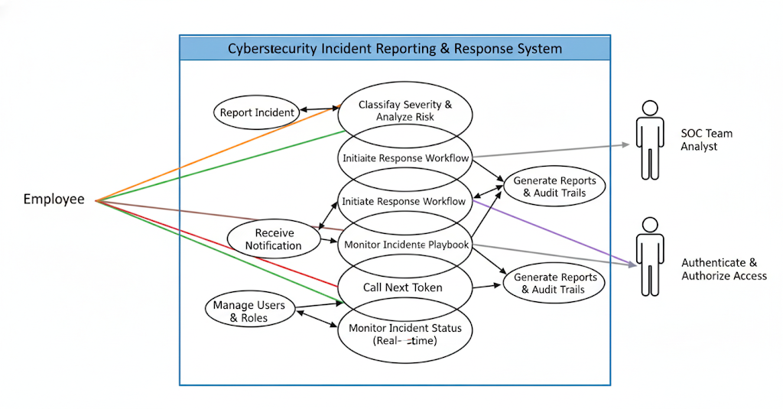

**15. Glossary Development - Create project glossary**

| **Term** | **Description** |
| --- | --- |
| Cybersecurity Incident Reporting & Response System | A centralized digital platform used to report, track, and manage cybersecurity incidents within an organization. |
| Cybersecurity Incident | Any event that compromises or threatens the confidentiality, integrity, or availability of information systems. |
| Incident Report | A formal record submitted by a user describing a suspected or confirmed security incident. |
| Severity Level | Classification of an incident based on its impact and urgency (Low, Medium, High, Critical). |
| Incident Lifecycle | The complete process of handling an incident from detection to closure. |
| SOC (Security Operations Center) | A team responsible for monitoring, analyzing, and responding to cybersecurity threats. |
| SOC Analyst | A security professional who investigates and responds to reported incidents. |
| Admin (System Administrator) | Authorized personnel responsible for managing users, configurations, and compliance records. |
| Response Workflow | A structured set of steps followed to mitigate and resolve a cybersecurity incident. |
| Alert / Notification | A system-generated message informing users or SOC teams about incident updates or critical events. |
| Audit Trail | A chronological record of all actions performed during an incident for accountability and compliance. |
| Compliance Documentation | Records maintained to meet regulatory and organizational security requirements. |
| Risk Analysis | The process of evaluating the potential impact and likelihood of a security incident. |
| Dashboard | A real-time visual interface displaying incident statistics, severity distribution, and system status. |
| Authentication | The process of verifying a user’s identity before granting system access. |
| Authorization | The process of granting permissions to users based on their assigned roles. |
| SRS (Software Requirements Specification) | A document that defines the functional and non-functional requirements of the system. |
| UI (User Interface) | The visual elements through which users interact with the system. |
| Incident ID | A unique identifier assigned to each reported incident. |
| Status Update | A change in the state of an incident (e.g., New, In Progress, Resolved, Closed). |

**16. Project Charter – Cybersecurity Incident Reporting & Response System**

**Project Title**

Cybersecurity Incident Reporting & Response System

**Project Overview**

The Cybersecurity Incident Reporting & Response System is a web-based software solution designed to centralize the reporting, tracking, and management of cybersecurity incidents within an organization. The system replaces fragmented and manual reporting methods such as emails, spreadsheets, and verbal communication with a structured digital platform.  
It enables employees and security teams to log incidents, classify severity, follow guided response workflows, and monitor incident status in real time. The project aims to improve organizational resilience, reduce incident response time, ensure compliance, and enhance overall cybersecurity incident management efficiency.

**Project Objectives**

The primary objectives of this project are:

* To provide a centralized platform for reporting cybersecurity incidents
* To reduce delays in incident detection and response
* To enable real-time tracking of incident status and severity
* To assist SOC teams in managing and responding to incidents efficiently
* To improve compliance, accountability, and audit readiness
* To develop a secure, reliable, and user-friendly incident response system using software engineering principles

**Project Scope**

The scope of this project includes the design and development of a **Cybersecurity Incident Reporting & Response System** that supports:

* Incident reporting by employees and authorized users
* Automated severity classification of incidents
* Incident lifecycle tracking from detection to closure
* Guided response workflows for SOC teams
* Real-time dashboards for monitoring incidents
* Notification and alert management
* Audit trails and compliance reporting

The system is strictly limited to incident reporting, tracking, and response coordination and does not perform direct threat mitigation or security enforcement actions.

**Stakeholders**

The key stakeholders involved in the project include:

* **Employees / Incident Reporters** – Users who report suspected or confirmed security incidents
* **SOC Analysts** – Security professionals responsible for analyzing and responding to incidents
* **System Administrator / Security Manager** – Responsible for system configuration, monitoring, and compliance
* **Organizational Management** – Sponsors interested in security posture and risk reduction
* **IT Support Team** – Responsible for system maintenance and technical support

**Project Deliverables**

The major deliverables of the project are:

* Software Requirements Specification (SRS) document
* Use Case Diagrams
* Class Diagram
* Sequence Diagrams
* Activity Diagrams
* Component Diagram
* Deployment Diagram
* System Design Document
* Final Mini Project Report

**Assumptions**

* The organization has basic IT infrastructure and secure servers
* Users have basic knowledge of using web-based systems
* Stable internet connectivity is available
* Users follow organizational security policies while using the system

**Constraints**

* The system does not directly mitigate or block cyber threats
* Integration with external security tools is outside the project scope
* The system must comply with organizational security and privacy policies
* Project development is limited to the academic timeline

**Risks**

* Network or server downtime may affect real-time incident tracking
* High volume of incidents may impact system performance
* Resistance to adoption by users unfamiliar with formal incident reporting
* Limited scalability due to academic project constraints

**Project Timeline (High-Level)**

* **Requirement Analysis & SRS:** Week 1–2
* **System Design & Diagrams:** Week 3–4
* **Documentation & Review:** Week 5
* **Final Submission:** Week 6

**17. Stakeholder Register Submission**

The stakeholder register is a formal document that identifies all stakeholders involved in the **Cybersecurity Incident Reporting & Response System**, along with their roles, interests, and influence levels. This register helps in understanding stakeholder expectations and managing their involvement throughout the project lifecycle.

| **Stakeholder** | **Role** | **Interests** | **Influence Level** |
| --- | --- | --- | --- |
| **Employees / Incident Reporters** | **End Users** | **Simple incident reporting, quick acknowledgment, system transparency** | **Medium** |
| **SOC Analysts** | **System Users** | **Efficient incident analysis, guided response workflows, real-time alerts** | **High** |
| **System Administrator / Security Manager** | **System Owner** | **Incident monitoring, user management, compliance tracking** | **High** |
| **Organizational Management** | **Project Sponsor** | **Reduced security risk, regulatory compliance, operational efficiency** | **High** |
| **IT Support Team** | **Technical Support** | **System reliability, security, maintenance, uptime** | **Medium** |
| **Compliance / Regulatory Authorities** | **Oversight Body** | **Adherence to security standards, audit readiness, accountability** | **Low to Medium** |

The stakeholder register is reviewed and approved to ensure that all relevant stakeholders are identified and that their expectations are addressed during the design, development, and implementation of the system.

**18. Complete Software Requirements Specification (SRS) Document**

The **Software Requirements Specification (SRS)** document for the **Cybersecurity Incident Reporting & Response System** has been prepared by consolidating all previously defined and approved sections. The document provides a comprehensive and structured description of system requirements to guide the design, development, and validation of the system.

The complete SRS document includes:

* Introduction and purpose of the system
* Problem statement and system objectives
* Overall system description and product perspective
* Scope definition and system boundaries
* Stakeholder analysis and user characteristics
* Functional requirements (FR-01 to FR-08)
* Non-functional requirements (NFR-01 to NFR-04)
* Use case diagrams and descriptions
* Glossary of terms and definitions

The SRS document adheres to standard software engineering and IEEE SRS documentation practices. It serves as a baseline reference for system design, implementation, testing, and future enhancements of the **Cybersecurity Incident Reporting & Response System**.

**19. Requirements Sign-off**

The requirements sign-off confirms that all identified stakeholders have reviewed and approved the requirements specified in the Software Requirements Specification (SRS) document for the Cybersecurity Incident Reporting & Response System. This approval signifies mutual agreement on the system’s functionality, scope, assumptions, constraints, and quality requirements as documented.

Any modifications or enhancements requested after this sign-off shall be handled through a formal change management process to ensure proper evaluation, documentation, and approval.

**Approved By:**  
Name:  
Role:

Signature:   
Date:

**20. CASE Tool Setup**

For the design phase of the **Cybersecurity Incident Reporting & Response System**, a **Computer-Aided Software Engineering (CASE) tool** was selected to efficiently create, manage, and maintain system design artifacts.

**Selected CASE Tool: StarUML**

**StarUML** was installed and configured on the development environment to support **UML-based system modeling**. The tool is used to design and document various system diagrams, including:

* Use Case Diagrams
* Class Diagrams
* Sequence Diagrams
* Activity Diagrams
* Component Diagrams
* Deployment Diagrams

**Benefits of the CASE Tool**

The selected CASE tool provides the following advantages:

* Support for standard UML notation
* Clear and consistent visualization of system architecture
* Ease of modification and maintenance of design diagrams
* Improved understanding and communication of system structure and behavior

The successful installation and configuration of the CASE tool ensures a **structured, systematic, and standardized approach** to the design and documentation of the **Cybersecurity Incident Reporting & Response System**.

**21. Team Workspace Setup**

A dedicated workspace was created within the **CASE tool environment** to support collaborative system design and maintain an organized project structure for the **Cybersecurity Incident Reporting & Response System**.

**Workspace Configuration**

The workspace setup includes:

* A separate project file created specifically for the system design
* Organized folders for different UML diagrams
* Clear and consistent naming conventions for diagrams and components

**Benefits of the Workspace Setup**

The structured workspace enables:

* Easy navigation and management of design artifacts
* Consistent documentation across all system diagrams
* Efficient collaboration among team members
* Simplified future updates and enhancements to system models

This workspace setup ensures a **systematic, well-organized, and collaborative approach** to designing and documenting the **Cybersecurity Incident Reporting & Response System**.

**22. Project Structure Creation**

The project structure within the **CASE tool** was designed to logically organize all UML diagrams related to the **Cybersecurity Incident Reporting & Response System**. The structure ensures clarity, consistency, and ease of maintenance throughout the system design phase.

**Project Structure**

The following structure was created:

* **Use Case Diagrams**
  + Employee / Incident Reporter Use Cases
  + SOC Analyst Use Cases
  + Administrator Use Cases
* **Class Diagrams**
  + Core System Classes
  + Supporting and Utility Classes
* **Sequence Diagrams**
  + Incident Reporting Flow
  + Severity Classification Flow
  + Incident Response Workflow
  + Notification and Alert Flow
* **Activity Diagrams**
  + Incident Reporting Activity Flow
  + SOC Response Workflow
* **Component Diagram**
  + System Architecture Components
* **Deployment Diagram**
  + System Deployment Environment

This structured organization of UML artifacts ensures a **clear understanding of system behaviour, architecture, and interactions**, thereby supporting effective design, collaboration, and future enhancements of the **Cybersecurity Incident Reporting & Response System**.

**23. Actors Identification**

Actors represent external entities that interact with the **Cybersecurity Incident Reporting & Response System**. Identifying actors helps in understanding system interactions and defining use cases.

The following actors have been identified:

* **Employee/ Incident Reporter**  
  Reports suspected or confirmed cybersecurity incidents and views incident status updates.
* **SOC Analyst**  
  Analyses reported incidents, performs severity assessment, follows response workflows, and updates incident status.
* **System Administrator / Security Manager**  
  Manages system users, roles, configurations, monitors incident activity, and generates compliance and audit reports.
* **Notification System**  
  Sends alerts and notifications to relevant stakeholders regarding incident reporting, severity changes, and status updates.

These actors interact with the system to ensure **efficient reporting, timely response, and effective management of cybersecurity incidents** across the organization.

**24. Use Case Definition**

Based on the identified actors, the core use cases of the **Cybersecurity Incident Reporting & Response System** are defined as follows:

1. **Report Incident** – Allows employees to submit cybersecurity incident reports.
2. **Classify Incident Severity** – Automatically or manually assigns severity levels to reported incidents.
3. **Track Incident Status** – Enables users to view the current status and progress of incidents.
4. **Initiate Response Workflow** – Allows SOC analysts to follow guided response steps.
5. **Update Incident Status** – Enables SOC analysts to update incident lifecycle stages.
6. **Manage Users and Roles** – Allows administrators to manage system users and permissions.
7. **User Authentication** – Verifies user identity and controls access based on roles.
8. **Monitor Incident Dashboard** – Provides real-time visualization of incidents and severity levels.
9. **Generate Reports and Audit Logs** – Produces compliance, audit, and performance reports.

These use cases collectively describe the **primary functionalities required for effective cybersecurity incident reporting, monitoring, and response management** within the organization.

**25. Use Case Relationships**

Use case relationships describe how different use cases within the **Cybersecurity Incident Reporting & Response System** are connected using **«include»** and **«extend»** relationships. These relationships help in modularizing functionality and avoiding redundancy.

**Include Relationships**

* **User Authentication** is included in:
  + Report Incident
  + Initiate Response Workflow
  + Update Incident Status
  + Monitor Incident Dashboard
  + Generate Reports and Audit Logs

(Users must be authenticated before performing any secure system operation.)

* **Track Incident Status** is included in:
  + Monitor Incident Dashboard
  + Generate Reports and Audit Logs

**Extend Relationships**

* **Send Notification** extends:
  + Report Incident
  + Update Incident Status

(Notifications are triggered only when specific events such as incident creation or status change occur.)

* **Classify Incident Severity** extends:
  + Report Incident

(Severity classification occurs after an incident is reported.)

These use case relationships ensure a **structured, reusable, and efficient system design**, supporting secure and streamlined cybersecurity incident management.

**26. Use Case Documentation**

. **Use Case 1: Report Incident**

**Actor:** Employee / Incident Reporter

**Precondition:**  
User is authenticated and has access to the system.

**Main Flow:**

1. User selects the option to report a new incident.
2. User enters incident details such as type, description, and time of occurrence.
3. System validates the entered information.
4. System generates a unique incident ID.
5. Incident is stored in the centralized incident repository.

**Alternative Flow:**

* If the system is unavailable or required details are missing, incident submission fails and an error message is displayed.

**Postcondition:**  
A valid cybersecurity incident is successfully reported and recorded in the system.

#### Use Case 2: Initiate Response Workflow

**Actor:** SOC Analyst

**Precondition:**  
SOC analyst is authenticated and an incident is assigned.

**Main Flow:**

1. SOC analyst selects an assigned incident.
2. System displays incident details and severity level.
3. System presents the guided response workflow.
4. SOC analyst performs response actions and updates progress.
5. Incident status is updated to “In Progress.”

**Alternative Flow:**

* If the incident is already resolved or closed, the system restricts workflow initiation.

**Postcondition:**  
Incident response process is initiated and tracked by the system.

**Use Case 3: Monitor Incident Performance**

**Actor:** System Administrator / Security Manager

**Precondition:**  
Administrator is authenticated.

**Main Flow:**

1. Administrator accesses the incident monitoring dashboard.
2. System displays real-time incident statistics and severity distribution.
3. Administrator reviews response timelines and performance metrics.

**Alternative Flow:**

* If no incidents are available, the system displays default or empty dashboard values.

**Postcondition:**  
Incident performance and system activity are successfully monitored.

**27. Class Identification**

Based on the requirements and use cases of the **Cybersecurity Incident Reporting & Response System**, the following core classes have been identified. These classes collectively model the structure and behavior of the system:

* **User**  
  Represents employees or security team members who interact with the system. Users can report incidents, view notifications, or track incident status based on their role.
* **Incident**  
  Captures all details related to a cybersecurity event, including description, timestamp, severity, status, and associated evidence.
* **SeverityLevel**  
  Classifies incidents according to their criticality (e.g., Low, Medium, High, Critical) to prioritize response workflows.
* **ResponseWorkflow**  
  Represents structured steps to mitigate or resolve an incident. It can include automated actions, guided procedures, and escalation paths.
* **Alert**  
  Encapsulates system-generated notifications triggered by new incidents, updates, or status changes, sent to relevant users or teams.
* **Admin**  
  Represents system administrators responsible for managing users, incidents, dashboards, and compliance settings.
* **AuditTrail**  
  Records all actions taken on an incident or within the system, including timestamps, user actions, and changes, ensuring accountability and compliance.
* **Report**  
  Generates analytical insights and summaries for management or compliance purposes, such as incident trends, response efficiency, and risk analysis.

**28. Class Attributes and Methods Definition**

| **Class Name** | **Attributes** | **Methods** |
| --- | --- | --- |
| **User** | **userId, name, role, loginStatus** | ReportIncident(), viewIncidentStatus(), receiveNotification() |
| **Incident** | **incidentId, description, timestamp, severityLevel, status, evidence** | **createIncident(), updateStatus(), assignSeverity(), attachEvidence()** |
| **SeverityLevel** | **levelId, levelName, priority** | **classifyIncident(), updatePriority()** |
| **ResponseWorkflow** | **workflowId, steps, assignedTeam, status** | **initiateWorkflow(), updateStepStatus(), escalateIncident()** |
| **Alert** | **alertId, messageContent, recipientUserId, timestamp** | **sendAlert(), markAsRead()** |
| **Admin** | **adminId, accessLevel** | **manageUsers(), manageWorkflows(), generateDashboardReport(), configureSystem()** |
| **AuditTrail** | **auditId, actionTaken, userId, timestamp, incidentId** | **recordAction(), viewTrail()** |
| **Report** | **reportId, reportType, reportData** | **createReport(), viewReport(), exportReport()** |

**29. Class Relationships**

The relationships among classes define how components of the system interact with each other:

* A **User** can report one or more **Incidents** (Association).
* An **Incident** is classified under one **SeverityLevel** (Association).
* A **Response Workflow** is linked to one **Incident** but may include multiple steps (Aggregation).
* An **Alert** is sent to one or more **Users** (Association).
* An **Admin** manages **Users**, **Response Workflows**, and **Reports** (Association).
* An **AuditTrail** records actions performed by **Users** or **Admins** on **Incidents** (Association).
* A **Report** is generated by an **Admin** and may include multiple **Incidents** (Aggregation).

These relationships are represented in the class diagram using **association** and **aggregation** relationships, showing how different system components are connected and interact.

**30. Sequence Diagrams Creation**

Sequence diagrams represent the chronological interaction between actors and system components for specific system operations. In the **Cybersecurity Incident Reporting & Response System**, sequence diagrams are used to visualize how users, admins, and system components interact during incident management activities.

The following sequence diagrams are created to capture critical system processes:

* **Incident Reporting Process**  
  Shows how a **User** reports a new incident, how it is recorded in the **Incident** class, classified by **SeverityLevel**, and notifications are sent via **Alert**.
* **Incident Response Workflow Process**  
  Illustrates how a **ResponseWorkflow** is triggered for a reported incident, steps are executed, and progress is updated for the **User** and **Admin** to monitor.
* **Alert Notification Process**  
  Represents how **Alerts** are generated and sent to relevant **Users** or **Security Teams** based on incident severity or workflow updates.
* **Admin Report Generation Process**  
  Demonstrates how an **Admin** accesses the system to generate **Reports** that summarize incidents, workflow statuses, and compliance information.

These diagrams help developers and stakeholders clearly understand the internal workings of the system, the responsibilities of each component, and the flow of information for efficient incident management.

**31. Object Interactions Documentation**

**Sequence Diagram 1:** Token Generation Process

**Actors & Modules:**

* Employee/User – Reports the incident
* Incident Reporting System – Receives and processes incidents
* Severity Module – Classifies the threat severity
* Response Workflow Module – Initiates guided response actions
* SOC Dashboard – Displays incident status to security teams

**Interaction Flow:**

1. Employee/User logs an incident.
2. Incident Reporting System validates incident details.
3. Severity Module classifies the severity (low, medium, high).
4. Response Workflow Module triggers the appropriate mitigation workflow.
5. SOC Dashboard updates in real-time with incident status and resolution steps.
6. Audit & Compliance Module logs all actions for accountability.

This ensures incidents are logged, classified, mitigated, and tracked in a structured, transparent, and auditable manner.

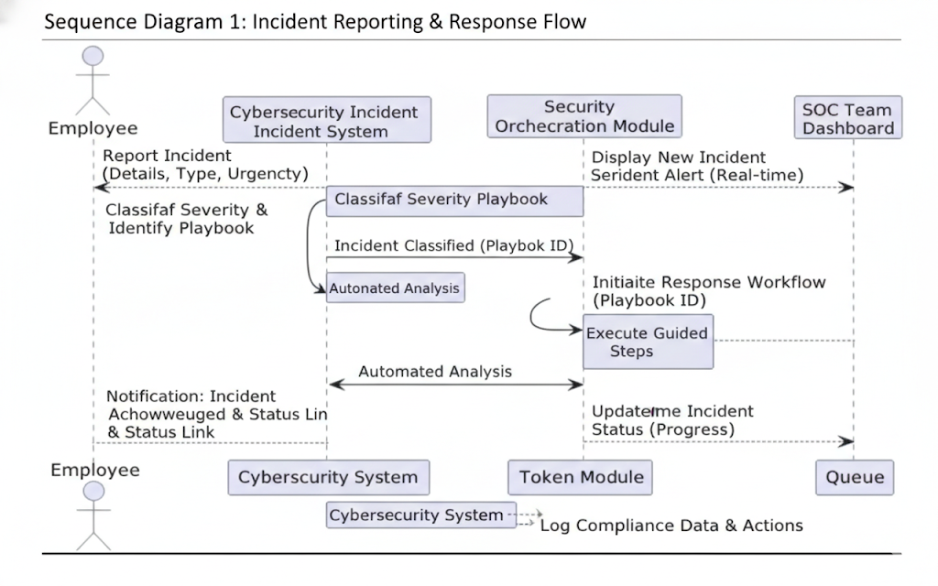

#### Sequence Diagram 2: Calling and Serving the Next Customer

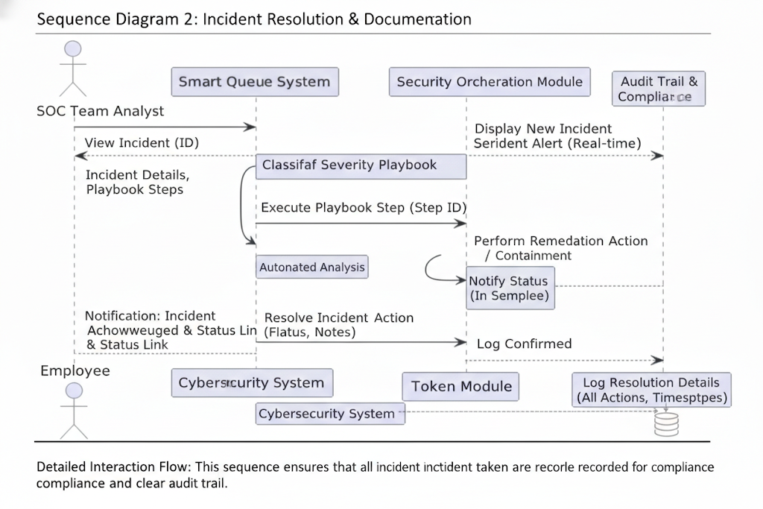

**Detailed Interaction Flow:**

**The employee logs into the system using secure authentication** to access the Cybersecurity Incident Reporting & Response Platform.

1. **The employee selects the option to report a new cybersecurity incident** and submits relevant details such as incident type, description, and affected assets.
2. **The system validates the incident submission** and automatically logs the report into the centralized digital command center.
3. **The Automatic Severity Classification module analyzes the incident** and determines its severity level based on predefined threat assessment rules.
4. **The classified incident is assigned to the Security Operations Center (SOC) team** for investigation and mitigation.
5. **The system updates the incident status in real time**, notifies relevant security personnel, and records all actions in the audit trail for compliance purposes.

This sequence ensures **rapid incident detection, accurate severity classification, coordinated response actions, and transparent monitoring**, enabling efficient threat mitigation and regulatory compliance.

**Sequence Diagram 3: Customer Notification Proces**

**Detailed Interaction Flow: Incident Status Notification Process**

1. **The system continuously monitors the status of reported cybersecurity incidents** within the centralized incident management platform.
2. **When a significant status change occurs** (such as severity escalation, mitigation start, or resolution), the system triggers a notification event.
3. **The Notification Service prepares and dispatches alert messages** to relevant stakeholders, including employees, SOC team members, and administrators.
4. **The recipients receive real-time notifications** informing them about incident progress, required actions, or resolution updates.

This process ensures **timely awareness, improved coordination, and proactive response**, reducing delays in threat mitigation and enhancing overall security operations efficiency.

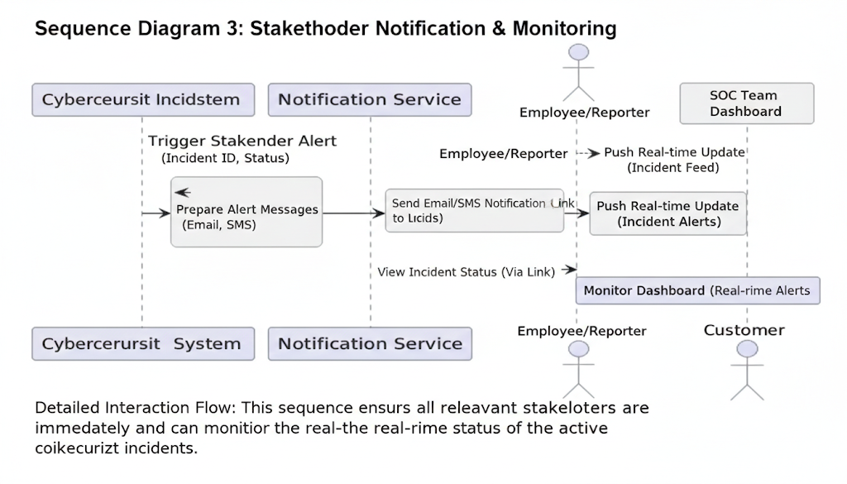

**Sequence Diagram 4: Administrative Queue Monitoring Process**

**Detailed Interaction Flow:**

1. **The administrator logs into the system using secure administrative credentials** to access privileged monitoring functions.
2. **The administrator accesses the real-time incident monitoring dashboard** within the Cybersecurity Incident Reporting & Response System.
3. **The system aggregates live incident data**, including incident counts, severity levels, response status, and active mitigation efforts.
4. **The Reporting and Analytics Module generates performance and compliance reports**, highlighting response times, resolution efficiency, and risk trends.
5. **The administrator reviews the dashboard and reports** to identify delays, bottlenecks, resource constraints, or recurring threat patterns.

This sequence enables **data-driven decision-making, efficient resource allocation, proactive threat management, and compliance oversight**, strengthening overall organizational security posture.

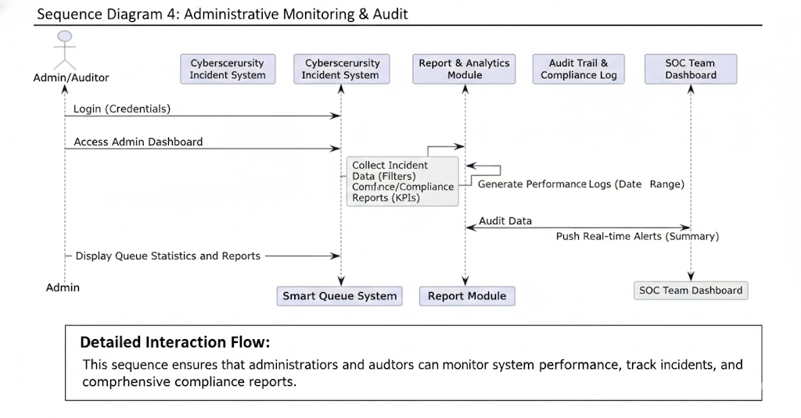

**32. Alternative Flows Inclusion**

Alternative flows represent exceptional conditions that may occur during normal system operation and describe how the system responds to such situations in a controlled and reliable manner.

**Alternative Flow 1: No Active Incident Scenario**

* If a security administrator or SOC analyst accesses the incident monitoring dashboard when no active cybersecurity incidents are present, the system displays a message indicating that there are currently no incidents requiring attention.

**Alternative Flow 2: System Unavailability**

* If the Cybersecurity Incident Reporting & Response System is temporarily unavailable due to maintenance or technical failure, incident submissions and monitoring actions are paused, and an appropriate notification is displayed to users informing them of the downtime.

**Alternative Flow 3: Notification Delivery Failure**

* If an incident notification fails to reach intended recipients due to network or service issues, the system logs the delivery failure in the audit trail and automatically retries sending the notification or escalates the alert through alternate communication channels.

**33. Activity Diagrams Creation**

Activity diagrams illustrate the workflow of actions performed by different actors within the system. For the **Cybersecurity Incident Reporting & Response System**, activity diagrams are used to represent how employees, security teams, and administrators interact with the system during incident reporting, monitoring, and response operations.

Two activity diagrams are created:

* **Employee (Incident Reporter) Activity Flow**
* **Security Operations Center (SOC) Workflow**

**Activity Diagram 1: Employee (Incident Reporter) Activity Flow**

This diagram depicts the sequence of actions an employee performs from detecting a cybersecurity threat to successfully submitting an incident report into the system.

The activity flow begins when the employee identifies a potential security incident. The employee then logs into the system using secure authentication and navigates to the incident reporting interface. Relevant incident details, such as incident type, description, and affected systems, are entered and submitted. The system validates the information and confirms successful incident registration, after which the incident enters the response workflow for further analysis and action by the security team.

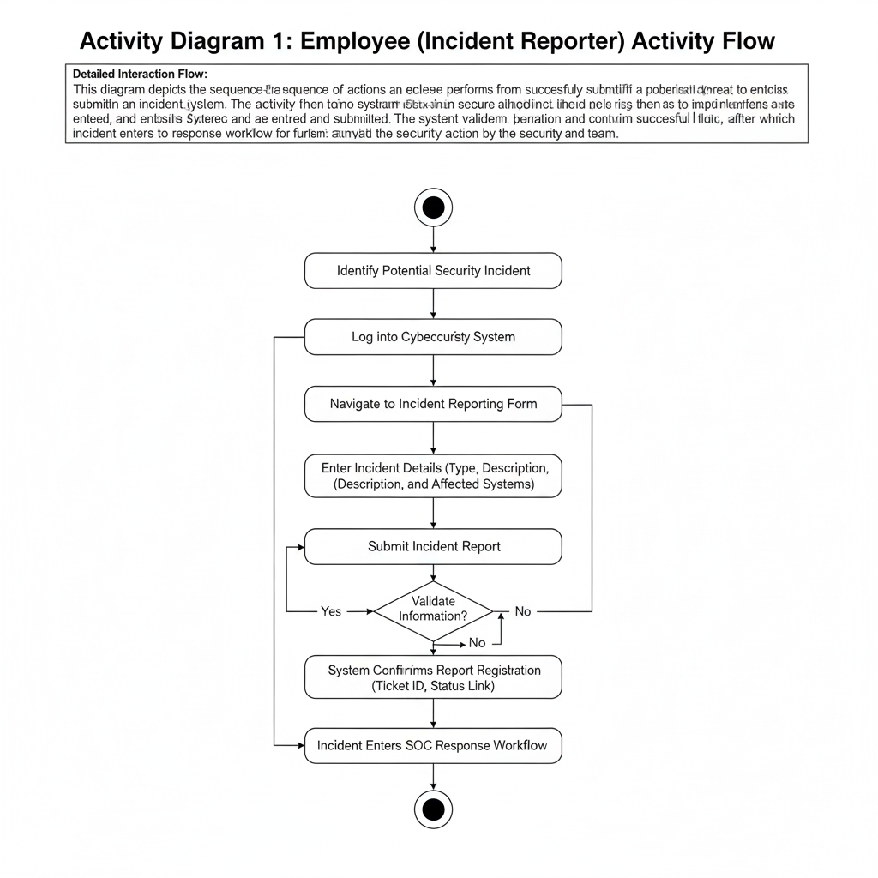

**Activity Diagram 2:** Teller Workflow

This diagram explains how a teller handles customers using the queue system

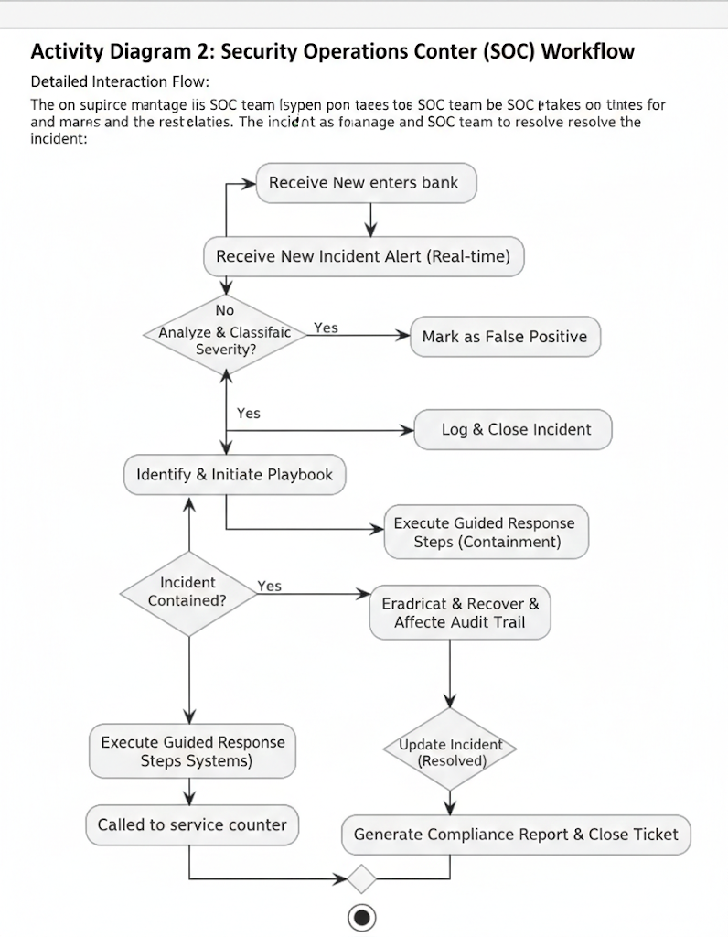

**34. Workflow Documentation**

Workflow documentation explains complex system processes using clear steps, decision points, and parallel activities. It helps in understanding how different components of the **Cybersecurity Incident Reporting & Response System** work together in real-world security scenarios.

**Workflow 1: End-to-End Cybersecurity Incident Response Workflow**

1. **An employee detects a potential cybersecurity incident** such as phishing, malware, or unauthorized access.
2. **The employee logs into the system securely** and submits an incident report with relevant details.
3. **The system validates the submission** and records the incident in the centralized command center.
4. **The Automatic Severity Classification Module analyzes the incident** and assigns a severity level.
5. **The incident is added to the active incident queue** for tracking and response.
6. **The system notifies the Security Operations Center (SOC)** about the newly reported incident.
7. **SOC analysts investigate the incident** and initiate appropriate mitigation actions.
8. **Incident status is continuously updated** as response actions progress.
9. **The incident is resolved and verified** by the security team.
10. **The incident is closed**, and all actions are recorded in the audit trail for compliance and future analysis.

This workflow ensures **rapid detection, structured response, real-time visibility, and regulatory compliance**, minimizing the impact of cybersecurity threats.

**Workflow 2: Security Operations Center (SOC) Incident Handling Workflow**

1. **SOC analyst logs into the system using privileged credentials.**
2. **The analyst views the active incident queue** along with severity levels and priority indicators.
3. **The analyst selects the highest-priority incident** based on risk and impact.
4. **The system retrieves incident details and historical context.**
5. **The analyst performs investigation and containment actions.**
6. **Mitigation steps are executed** following guided response workflows.
7. **Incident status is updated in real time** within the system.
8. **Once resolved, the incident is marked as closed**, and post-incident documentation is completed.

This workflow improves **response efficiency, prioritization accuracy, collaboration, and accountability** within security teams.

**35. Component Diagram Creation**

The component diagram represents the high-level software architecture of the **Cybersecurity Incident Reporting & Response System**. It illustrates how major system components interact with each other to support incident reporting, severity assessment, response coordination, monitoring, and compliance management.

**Identified Components**

* **User Interface (Employee Portal, SOC Dashboard & Admin Console)**  
  Provides interfaces for employees to report incidents, SOC teams to manage responses, and administrators to monitor system performance.
* **Incident Reporting Module**  
  Captures incident details submitted by users and validates the input before forwarding it for analysis.
* **Severity Classification & Risk Analysis Module**  
  Automatically evaluates reported incidents and assigns severity levels based on predefined rules and threat indicators.
* **Incident Management & Response Workflow Module**  
  Manages incident lifecycle stages, including assignment, investigation, mitigation, escalation, and closure.
* **Notification & Alert Service**  
  Sends real-time alerts and updates to employees, SOC analysts, and administrators through multiple communication channels.
* **Reporting & Compliance Module**  
  Generates incident reports, audit logs, compliance documentation, and performance analytics.
* **Authentication & Authorization Module**  
  Ensures secure access control by verifying user identities and enforcing role-based permissions.
* **Centralized Incident Database**  
  Stores incident records, user data, response actions, audit trails, and historical analytics.

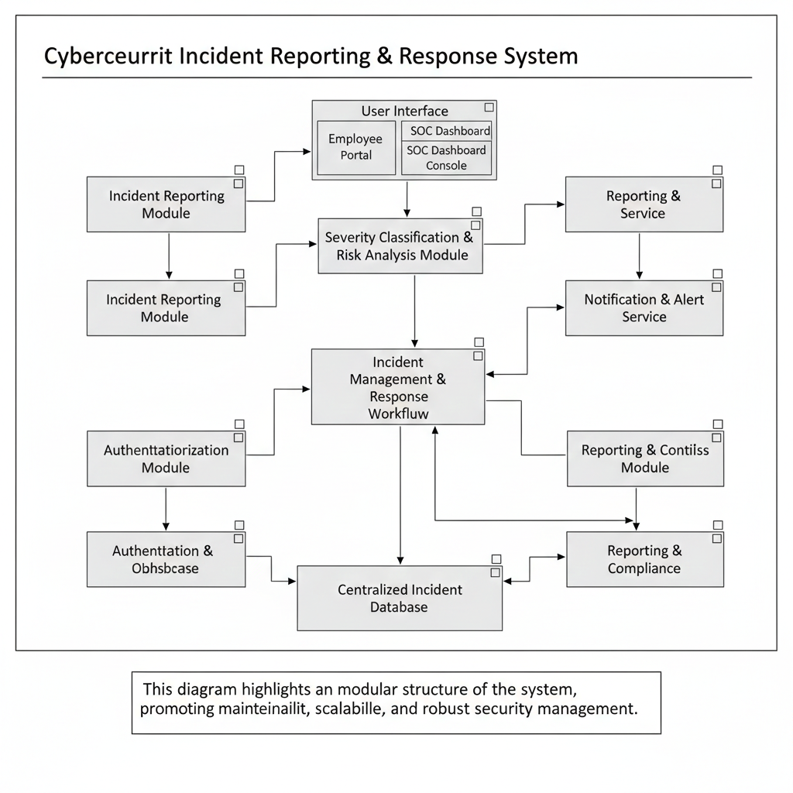

**36. Deployment Diagram Creation**

The deployment diagram illustrates the physical environment in which the **Cybersecurity Incident Reporting & Response System** is deployed. It shows the hardware nodes and their connections.

**Deployment Environment**

· Employee / User Device

· Security Analyst / SOC Workstation

· Application Server

· Database Server

· Admin / Management Dashboard

· Network (Internet / LAN / VPN)

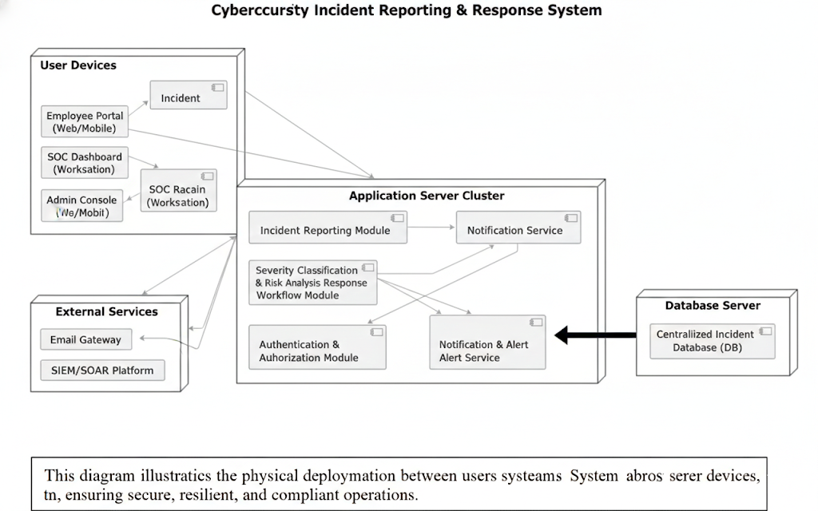

**37. Design Document Creation**

The design document explains the architectural and design decisions made during the development of the **Cybersecurity Incident Reporting & Response System**. The system is designed using a **modular and layered approach** to improve maintainability, clarity, and scalability.

**Design Decisions**

· A modular architecture is used to separate **incident reporting, severity classification, response workflow management, notification, and audit tracking**.

· **UML diagrams** are used to visually represent system structure (class diagrams) and behavior (sequence and activity diagrams).

· **Security** is handled through **role-based authentication** for employees, SOC analysts, and administrators.

· The **database is centralized** to maintain **data consistency, integrity, and compliance**.

**Assumptions**

· The system is deployed within the organization’s **network infrastructure**.

· Users have **basic digital literacy**.

· Internet or local network connectivity is available during **working hours**.

**Limitations**

· The system does not directly **block or remove cyber threats**; it only supports reporting and response.

· Advanced AI-based threat prediction is **not included**.

· Integration with **external SOC tools or third-party security platforms** is not supported in this version.

**Scalability Considerations**

· The system can be extended to support **multiple offices or SOC teams**.

· Additional **incident types or reporting modules** can be added easily.

· Notification methods can be expanded to include **SMS, email, or real-time dashboard alerts**.

This design ensures that the **Cybersecurity Incident Reporting & Response System** meets functional requirements while remaining **robust, secure, and suitable for academic implementation**.